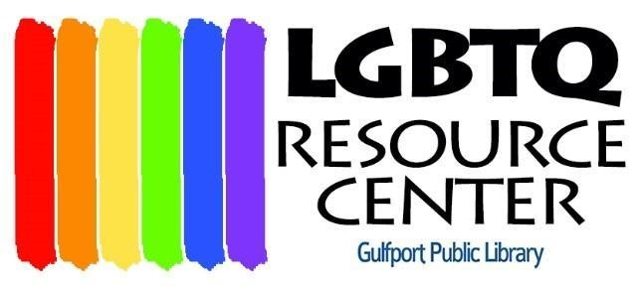

FOR IMMEDIATE RELEASE
CONTACT: Susan Gore, 727.537.6656

LGBTQ RESOURCE CENTER NAMES THREE BRANCHOUT SCHOLARS for 2023-2024
Gulfport, FL – October 11, 2023 - Bryan Hinkson, June Parlett Norsworthy and Jamie Riley receive $2000 scholarships from the LGBTQ Resource Center.
“Knowledge is at the heart of the LGBQ Resource Center’s mission,” says Board President Susan Gore. “Thanks to the Raymond James Pride Inclusion Network, we are able to offer three $2000 scholarships this year for LGBTQ students’ continuing education.” Two unique things about BranchOUT scholarships are that they may be used for any accredited educational program, not just university, and there is no upper age limit for participating.
Bryan Hinkson is a proud Suncoast Softball Hall of Fame member and graduate of George Mason University in TV and Radio Broadcasting. His voice is familiar to night owls who faithfully tune into the award-winning Big Gay Radio Show from midnight to 3 a.m. on WMNF 88.5 FM. There, Bryan and cohosts Esme Russell and Chris Gorman talk, entertain, and discuss community issues on the only LGBTQIA+ show in Tampa. Bryan is also a Graphic Design Intern at Cox Media. He will use his scholarship to complete studies at St. Petersburg College with the goal of becoming a full-time Graphic Designer.
June Parlett Norsworthy has spent more than 50 years documenting lesbian lives and art by women who had been left out of history. Subjects have ranged from fine artists to the Michigan Womyn’s Music Festival and TIGLFF. For 37 years June supported herself, her daughter and her passion, photography, as a Registered Nurse. Now in retirement, June completed the Digital Photography Certificate Program at St. Petersburg College in May 2023. Her goal is to raise awareness of lesbians’ contributions to art and music through online images and videos.
Jamie Riley’s path has led from anthropology, PR, and teaching elementary school in Korea, North Carolina and Taiwan to a new direction, studying for an MDiv in Interfaith Chaplaincy. He is currently a Chaplain Intern at BayCare Hospital, with the goal of becoming, in his words, “a visibly queer Buddhist hospital chaplain.” Riley also performs stand-up at Spitfire Comedy Club in St. Petersburg.

###

